22 July, 2025

**PRESS RELEASE**

###### TOURISM STATISTICS 2024

**Travelers**

The movement of travelers to and from Cyprus in 2024 recorded an increase compared to 2023. Total arrivals of travelers reached 6.285.427 recording an increase of 2,9% and departures totaled 6.270.760, also recording an increase of 2,7%, compared to 2023 (Figure 1).

Air traffic accounted for 97,7% of both arrivals and departures in 2024.

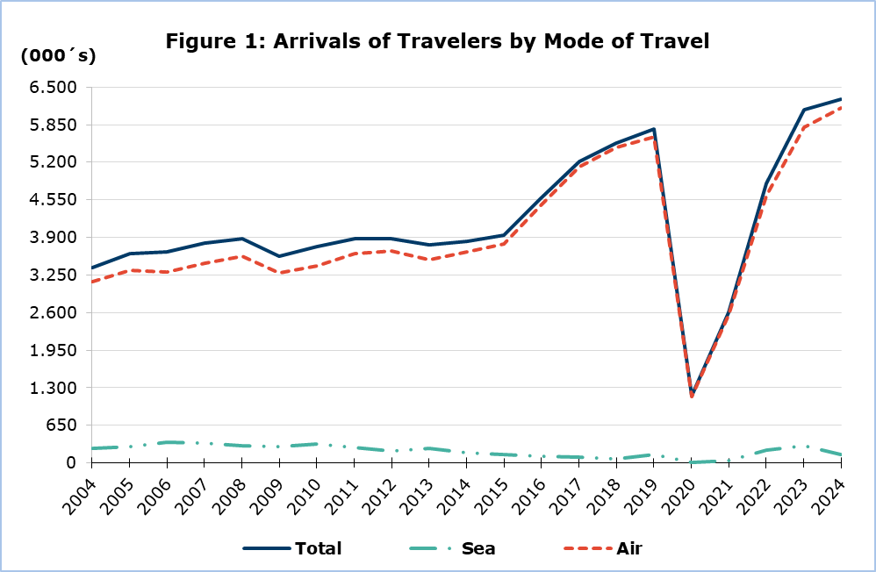

**Tourists**

Tourist arrivals increased by 5,1% and reached 4.040.200 in 2024 compared to 3.845.652 in 2023 (Figure 2).

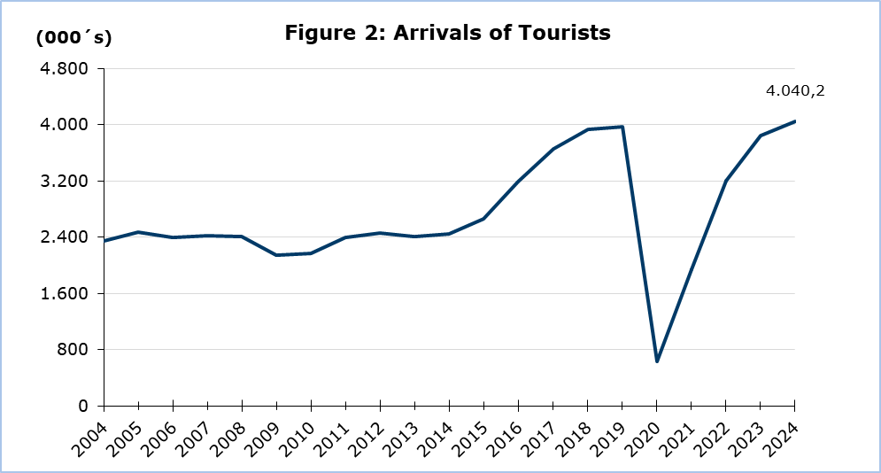

During 2024, the United Kingdom was the most important source of tourism for Cyprus with a share of 34,0% of the total tourist traffic, followed by Israel with 10,5%, Poland with 8,3%, Germany with 5,7%, Greece with 4,5% and Sweden with 3,7% (Figure 3).

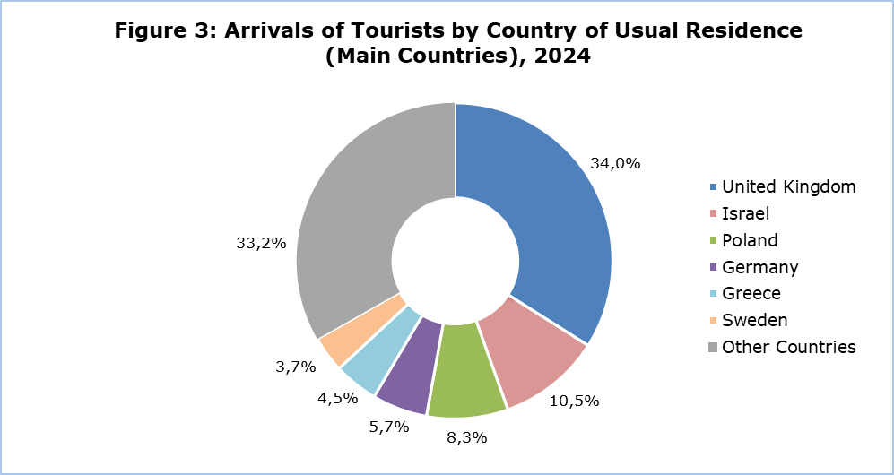

Out of the total number of tourists, 31,5% stated that they stayed in Pafos, 15,9% in Ayia Napa, 14,2% in Larnaka, 12,4% in Limassol, 11,4% in Paralimni and smaller proportions in other areas.

For a percentage of 81,1% of tourists, the purpose of their trip in 2024 was holidays, for 11,9% visit to friends and relatives and for 6,9% business.

**Revenue from Tourism**

In 2024, revenue from tourism was estimated at €3.209,4 mn, compared to €2.990,6 mn in 2023, recording an increase of 7,3%.

The average expenditure per person was €794,40 in 2024, recording an increase of 2,1% from 2023. The highest average expenditure per person in 2024 was recorded in the month of August with €921,59 and the lowest in the month of January with €513,32 (Figure 4).

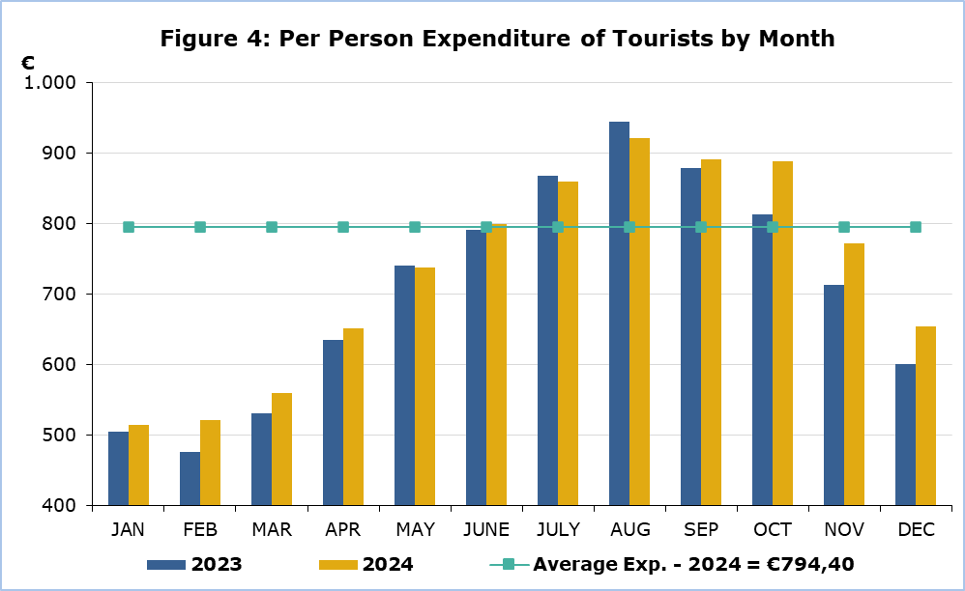

**Residents of Cyprus**

The trips of residents of Cyprus abroad increased by 4,4% in 2024, and reached 1.754.937 as compared to 1.680.345 in 2023.

In 2024 34,7% visited Greece, 10,5% the United Kingdom, 5,2% Italy, 3,7% Germany, 3,1% Russia and 2,9% France. The highest number of trips for residents was recorded in the month of August, while the lowest number of trips in February.

A percentage of 72,5% of the residents of Cyprus traveling abroad in 2024 stated that the main reason for traveling was holidays, 19,4% stated professional reasons, 6,8% studies and 1,3% other purposes.

**METHODOLOGICAL NOTES**

**Definitions**

**Travelers -** Are all persons who pass through passport control at the ports and airports of Cyprus. The various categories of travelers are visitors, residents and emigrants or immigrants.

**Tourists** - Are visitors staying at least one night in Cyprus.

**Revenue from Tourism -** It refers to the revenue from tourists during their visit to Cyprus.

**Residents of Cyprus -** This category includes persons who have resided in Cyprus for at least 12 months prior to their travel.

**Source of Data and Coverage**

The data are obtained from the Passengers Survey which is carried out at the points of arrival in Larnaka and Pafos airports. Additionally, data are also collected from administrative sources, such as the monthly arrivals from ports.

The data covers all persons who pass through passport control at the ports and airports in the Government controlled area of Cyprus. It does not include travelers who arrive and depart illegally via ports and airports in the occupied part of Cyprus.

The grossing - up is conducted based on the data sent to the Statistical Service by the Civil Aviation Department and from the cruise passenger lists, as well as on the data sent by other administrative sources.

During the period of June 2020 – April 2022, the Passengers Survey at Arrivals was temporarily discontinued and the data were obtained from the electronic platform “Cyprus Flight Pass”.

***For more information:***

CYSTAT Portal, subtheme [Tourism](https://www.cystat.gov.cy/en/SubthemeStatistics?s=51)

[CYSTAT-DB](https://cystatdb.cystat.gov.cy/pxweb/en/8.CYSTAT-DB/8.CYSTAT-DB__Tourism) (Online Database)

[Publications](https://www.cystat.gov.cy/en/PublicationList?s=51)

[Methodological Information](https://www.cystat.gov.cy/en/MethodologicalDetails?m=2172)

*Contact*

Lucy Panayidou: Tel.:+35722602152, E-mail: [lpanagidou@cystat.mof.gov.cy](mailto:lpanagidou@cystat.mof.gov.cy)